**Create a Workflow using SharePoint designer 2010**

Create a List Leave management

Create Announcement List

To create an approval workflow in SharePoint Designer 2013, go to the SharePoint Designer start page, select the site that has a list created before.

Select “Workflows” on the left navigation pane.

Create New List Workflow

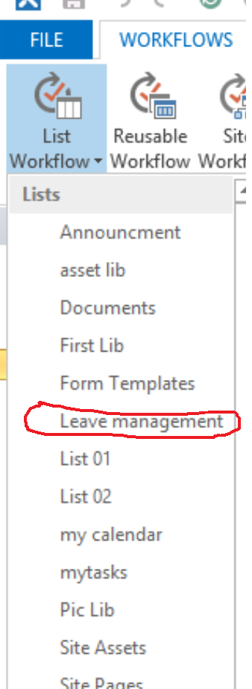

Then add and action run in parallel

Add action 🡪 Set workflow status to Starting

Add action email to created by

Add a step

Add if statement current Item equals Holiday

Add an action 🡪 create a Announcement item

Add Else

Add if statement current item leave type equals Business trip

Assign a task (book a meeting room) to jenkinsns

Then set workflow status to completed

Test the Workflow

Create a holiday item and verify the announcement

Create Business trip and complete the meeting room booking.